International Economics, 10e (Krugman/Obstfeld/Melitz)
Chapter 17 (6) Output and the Exchange Rate in the Short Run

17.1 Determinants of Aggregate Demand in an Open Economy

1) How does an increase in the real exchange rate affect exports and imports?
A) Exports increase; imports decrease.
B) Exports decrease; imports increase.
C) Exports increase; imports change ambiguously.
D) Exports change ambiguously; imports decrease.
E) Exports increase; imports are constant.
Answer: C
Page Ref: 451-455
Difficulty: Easy

2) Which one of the following statements is MOST accurate?
A) In general, consumption demand rises by less than disposable income.
B) In general, consumption demand rises by more than disposable income.
C) In general, consumption demand rises by more than income.
D) In general, consumption demand rises by the same amount as disposable income rises.
E) In general, consumption demand rises are unrelated to disposable income rises.
Answer: A
Page Ref: 451-455
Difficulty: Easy

3) The current account balance is
A) the supply of a country's exports less the country's own demand for imports.
B) the demand for a country's exports plus the country's own demand for imports.
C) the country's own demand for imports less the demand for a country's exports.
D) the demand for a country's exports less the country's own demand for imports.
E) the country's federal reserves minus the national debt.
Answer: D
Page Ref: 451-455
Difficulty: Easy

4) The domestic currency price of a representative foreign expenditure basket is
A) P, the domestic price level.
B) E, the nominal exchange rate.
C) P times E, the domestic price level times the domestic price level.
D) P, the foreign price level.
E) P times E, the foreign price level times the nominal exchange rate.
Answer: E
Page Ref: 451-455
Difficulty: Easy
5) Current account is given by the equation:
A) CA = IM - EX (measured in terms of domestic output).
B) CA = IM - EX (measured in terms of foreign output).
C) CA = EX - IM (measured in terms of domestic output).
D) CA = EX - IM (measured in terms of foreign output).
E) CA = EX + IM (measured in terms of domestic output).
Answer: C
Page Ref: 451-455
Difficulty: Easy

6) The domestic currency price of a representative domestic expenditure basket is
A) P, the domestic price level.
B) E, the nominal exchange rate.
C) P times E, the domestic price level times the domestic price level.
D) P, the foreign price level.
E) P times E, the foreign price level times the nominal exchange rate.
Answer: A
Page Ref: 451-455
Difficulty: Easy

7) The real exchange rate, q, is defined as
A) the price of the foreign basket in terms of the domestic one.
B) the price of the domestic basket in terms of the foreign one.
C) the price of the foreign basket.
D) the price of the domestic basket.
E) the nominal exchange rate in terms of the domestic basket.
Answer: A
Page Ref: 451-455
Difficulty: Easy

8) A country's domestic currency's real exchange rate, q, is defined as
A) E.
B) E times P.
C) E times P.
D) (E times P)/P.
E) P/(E times P).
Answer: D
Page Ref: 451-455
Difficulty: Easy

9) If the representative basket of European goods and services costs 40 euros, the representative U.S. basket costs $50, and the dollar/euro exchange rate is $0.90 per euro, then the price of the European basket in terms of U.S. basket is
A) [(0.9 $/euro) (40 euro per a European basket)]/[(50 $/U.S. basket)].
B) [(0.9 $/euro) (50 $/U.S. basket)]/[(40 euro per a European basket)].
C) [(40 euro per a European basket)]/[(50 $/U.S. basket) (0.9 $/euro)].
D) [(50 $/U.S. basket)].
E) [(0.9 $/euro) (40 euro per a European basket) (50 $ U.S. basket)].
Answer: A
Page Ref: 451-455
Difficulty: Easy
10) When EP/P rises
A) IM will rise.
B) IM will fall.
C) IM may rise or fall.
D) IM is not affected.
E) IM and P* will both rise.
Answer: C
Page Ref: 451-455
Difficulty: Easy

11) When the real exchange rate rises
A) imports measured in terms of domestic output will rise.
B) imports measured in terms of domestic output will fall.
C) imports measured in terms of domestic output will never be affected.
D) imports measured in terms of domestic output may rise or fall.
E) imports measured in terms of foreign output will rise.
Answer: D
Page Ref: 451-455
Difficulty: Easy

12) Which one of the following statements is the MOST accurate?
A) An increase in disposable income improves the current account.
B) An increase in disposable income does not affect the current account.
C) An increase in disposable income worsens the current account.
D) An increase in income worsens the current account.
E) An increase in income improves the current account.
Answer: C
Page Ref: 451-455
Difficulty: Easy

13) Which one of the following statements is the MOST accurate?
A) An increase in the real exchange rate and an increase in disposable income improve the current account.
B) A decrease in the real exchange rate and a decrease in disposable income improve the current account.
C) A decrease in the real exchange rate and a increase in disposable income improve the current account.
D) An increase in the real exchange rate and a decrease in disposable income improve the current account.
E) An increase in the real exchange rate and a decrease in disposable income lowers the current account.
Answer: D
Page Ref: 451-455
Difficulty: Easy
14) Disposable income is defined as
A) Y - C.
B) Y - T.
C) C - T.
D) I - C.
E) Y - I.
Answer: B
Page Ref: 451-455
Difficulty: Easy

15) The real exchange rate is:
A) how much of a foreign currency you can buy with the domestic currency.
B) foreign CPI divided by the domestic CPI.
C) the price of foreign goods in terms of domestic goods.
D) the price of foreign goods in dollars.
E) the domestic currency divided by the price level.
Answer: C
Page Ref: 451-455
Difficulty: Easy

16) An increase in the real exchange rate
A) makes imports more expensive.
B) makes imports less expensive.
C) does not affect import values.
D) always makes the number of imports rise.
E) makes domestic consumers spend more on only foreign imports.
Answer: A
Page Ref: 451-455
Difficulty: Easy

17) Which of the following compete to determine whether the current account improves or worsens following a rise in the real exchange rate?
A) appreciation and depreciation
B) crowding Out effect and producers effect
C) volume effect and value effect
D) volume effect and inflation
E) producers effect and value effect
Answer: C
Page Ref: 451-455
Difficulty: Easy

18) Assuming that the value effect dominates, the current account will increase if
A) the real exchange rate decreases.`
B) the real exchange rate increases.
C) disposable income increases.
D) exports fall.
E) domestic prices fall.
Answer: A
Page Ref: 451-455
Difficulty: Easy
19) Which of the following would cause the current account to decrease?
A) an increase in the nominal exchange rate, E
B) an appreciation of the home currency
C) an increase in disposable income
D) an increase in foreign prices, P
E) a decrease in domestic prices, P
Answer: C
Page Ref: 451-455
Difficulty: Easy

20) What is the best way to describe aggregate demand?
A) quantity required to satisfy equilibrium
B) exports decrease; imports increase
C) amount of a country's goods and services demanded by household and firms throughout the world
D) individual's demand
E) domestic demand of foreign imports.
Answer: C
Page Ref: 451-455
Difficulty: Easy

21) What have we assumed when we conclude that a real depreciation of the currency improves the current account?
A) The volume effect outweighs the value effect.
B) The value effect outweighs the volume effect.
C) All else equal and the volume effect outweighs the value effect.
D) All else equal and the value effect outweighs the volume effect.
E) All else equal and the volume effect equals the value effect.
Answer: C
Page Ref: 451-455
Difficulty: Easy

22) A country's domestic currency's real exchange rate, q, is best described by
A) the price of similar goods in the same market.
B) the price of the domestic basket in terms of the foreign one.
C) the price of a domestic basket.
D) the price of the foreign basket in terms of the domestic basket.
E) the price of different goods baskets in the same market.
Answer: D
Page Ref: 451-455
Difficulty: Easy

23) Explain how does an increase in the real exchange rate affect exports and imports?
Answer: When the real exchange rate increases, domestic products are cheaper relative to foreign products. Due to this, exports increase as foreigners demand more of our exports. The change in imports is ambiguous because fewer units of imports are purchased (the volume effect), but each foreign unit is now more expensive (the value effect). Remember: exports and imports are measured in terms of domestic output, i.e. dollar value, not volume of units. However, we often assume that the volume effect outweighs the value effect, so that imports decrease when the real exchange rate rises.
Page Ref: 451-455
Difficulty: Moderate
24) Please discuss the volume effect and the value effect in regards to how the current account will move given a change in the real exchange rate.
Answer: The volume effect takes place when consumer spending shifts on export and import quantities, while the value effect results when the domestic output worth of a given amount of foreign imports is changed. It is assumed that the volume effect outweighs the value effect, so that, other things equal, a real depreciation of the currency improves the current account.
Page Ref: 451-455
Difficulty: Moderate

25) What is the real exchange rate? What is its relationship to the current account?
Answer: Defined as: EP/P (the exchange rate multiplied by foreign prices, divided by domestic prices).
While the nominal exchange rate measures how much of a foreign currency one can buy with a unit of domestic currency, the real exchange rate measures how many goods and services one could buy.
A rise in the real exchange rate (a depreciation of domestic currency) means that domestic goods are cheaper compared to foreign goods, so exports increase and imports decrease. Aggregate demand increases and the CA rises. A fall in the real exchange rate has the opposite effect: Aggregate demand decreases and the CA falls.
Page Ref: 451-455
Difficulty: Moderate

26) Monetary expansion causes the current account balance to increase in the short run. Discuss. Is the same the case for fiscal expansion?
Answer: Am increase in the money supply leads to an increase in Y and E (output increases and the currency depreciates, respectively). Because of the currency depreciation, domestic goods are now cheaper compared to foreign goods. Exports increase and imports decrease, therefore the CAB increases.
An expansion of fiscal policy actually reduces the CAB: the DD curve is shifted right. Therefore Y rises, but E falls (output rises but the currency appreciates.) Domestic goods are more expensive, and the CAB falls.
Page Ref: 451-455
Difficulty: Moderate

27) Find the real exchange rate for the following case: Assume that the representative basket of European goods and services costs 40 euros and the representative U.S. basket costs $50, and the dollar/euro exchange rate is $0.90 per euro, then the price of the European basket in terms of U.S. basket is ________.
Answer: [(0.9 $/euro) (40 euro per a European basket)]/[(50 $/U.S. basket)]
Page Ref: 451-455
Difficulty: Moderate

28) Find the real exchange rate for the following case: Assume that the representative basket of European goods costs 150 euros and the representative U.S. basket costs $90, and the dollar/euro exchange rate is $0.80 per euro, then the price of the European basket in terms of U.S. basket is:
Answer: [(0.80 $/euro) (150 euro per a European basket)]/[(90 $/U.S. basket)] = 1.33 U.S. baskets/European basket.
Page Ref: 451-455
Difficulty: Moderate
29) Find the real exchange rate for the following case: Assume that the representative basket of European goods costs 150 euros and the representative U.S. basket costs $200, and the dollar/euro exchange rate is $1.20 per euro, then the price of the European basket in terms of U.S. basket is:
Answer: [(1.20 $/euro) (150 euro per a European basket)]/[(200 $/U.S. basket)] = 0.9 U.S. baskets/European basket.
Page Ref: 451-455
Difficulty: Moderate

30) Find the real exchange rate for the following case: Assume that the representative basket of European goods costs 100 euros and the representative U.S. basket costs $125, and the dollar/euro exchange rate is $0.75 per euro, then the price of the European basket in terms of U.S. basket is:
Answer: [(0.75 $/euro) (100 euro per a European basket)]/[(125 $/U.S. basket)] = 0.60 U.S. baskets/European basket.
Page Ref: 451-455
Difficulty: Moderate

31) Fill in the following table.

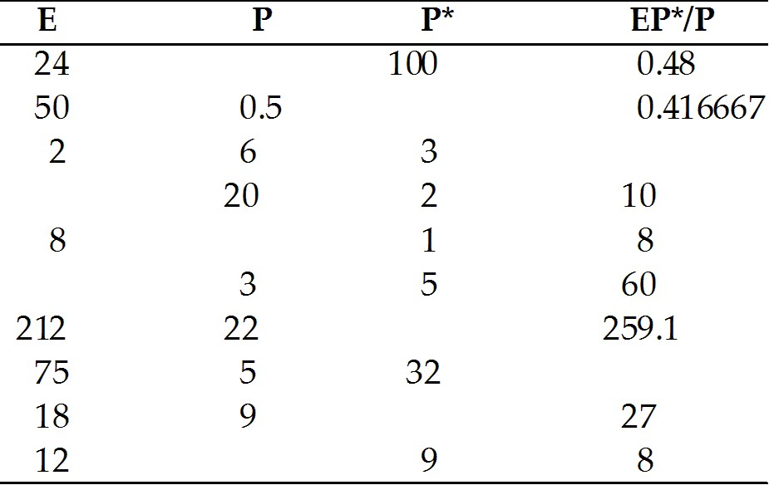
Answer:
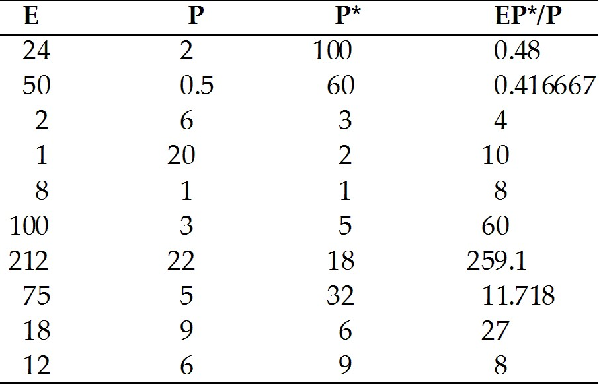
Page Ref: 451-455
Difficulty: Moderate
32) Fill in the following table.

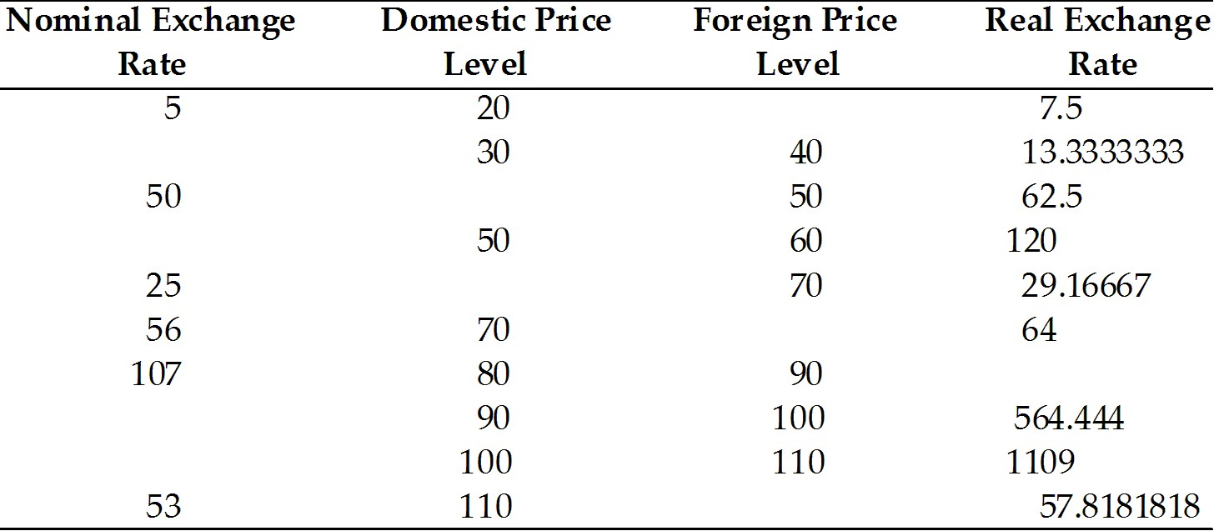
Answer:
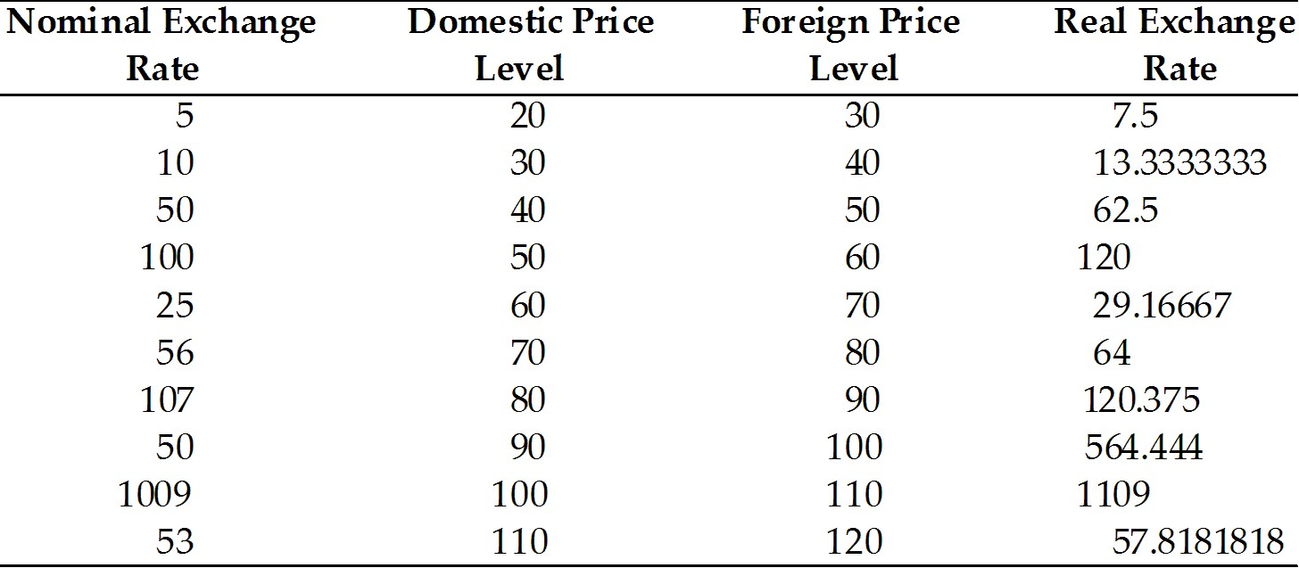
Page Ref: 451-455
Difficulty: Moderate

17.2 The Equation of Aggregate Demand

1) How does a rise in real income affect aggregate demand?
A) Y ↑ implies Yd ↑ implies Im ↑ implies CA ↓ implies AD ↓, but Y ↑ implies Yd ↑ implies C ↑ implies AD ↑ by more.
B) Y ↑ implies Yd ↑ implies Im ↓ implies CA ↓ implies AD ↓, but Y ↑ implies Yd ↑ implies C ↑ implies AD ↑ by more.
C) Y ↑ implies Yd ↑ implies Im ↑ implies CA ↑ implies AD ↑, and Y ↑ implies Yd ↑ implies C ↑ implies AD ↑.
D) Y ↑ implies Yd ↑ implies Im ↑ implies CA ↓ implies AD ↓, but Y ↑ implies Yd ↑ implies C ↑ implies AD ↑ by less.
E) Y ↑ implies Yd ↑ implies Im ↓ implies CA ↓ implies AD ↓, but Y ↑ implies Yd ↑ implies C ↑ implies AD ↑ by less.
Answer: A
Page Ref: 455-456
Difficulty: Easy
2) Which one of the following statements is the MOST accurate?
A) A rise in domestic real income raises aggregate demand for home output.
B) A rise in domestic real income decreases aggregate demand for home output because of the increase demand for import.
C) A rise in domestic real income keeps aggregate demand for home output at the same level.
D) It is difficult to tell whether a rise in domestic real income affects positively or negatively aggregate demand for home output.
E) A rise in domestic real income decreases aggregate demand for home output because the CA is raised.
Answer: A
Page Ref: 455-456
Difficulty: Easy

3) The aggregate demand for home input can be written as a function of:
I. Real exchange rate.
II. Government spending.
III. Disposable income.
A) I only
B) III only
C) I and III
D) II and III
E) I, II, and III
Answer: E
Page Ref: 455-456
Difficulty: Easy

4) What is an accurate implication resulting from an increase in income?
A) an increase in exchange rate
B) a decrease in exchange rate
C) a decrease in consumption
D) a decrease in output
E) an increase in consumption
Answer: E
Page Ref: 455-456
Difficulty: Easy

5) Explain how does a rise in real income affect aggregate demand?
Answer: A rise in domestic real income, Y, leads to a rise in disposable income, Yd. This raises the spending on imports, IM, thus lowering the current account, CA, and reducing aggregate demand, AD. However, the rise in Yd also causes a rise in consumption, C, and raises aggregate demand, AD, by more than the corresponding decrease.
Page Ref: 455-456
Difficulty: Easy
6) Explain the difference between the following two expressions:
Y = C(Yd) + I + G + CA(EP/P, Yd) and
Y = C + I +G + CA
Answer: The first one represents a behavioral equation and thus may express equilibrium condition for the output market or the aggregate desired demand for output. The second equation is only an identity that is always true.
Page Ref: 455-456
Difficulty: Moderate

17.3 How Output Is Determined in the Short Run

1) Which one of the following statements is MOST accurate?
A) Factors of production can only be over-employed in the short run.
B) Factors of production can only be under-employed in the short run.
C) Factors of production can be over- or under-employed in the long run.
D) Factors of production can be over- or under-employed in the short run.
E) Factors of production are fully employed in the short run.
Answer: D
Page Ref: 457-458
Difficulty: Easy

2) In the short-run, any rise in the real exchange rate, EP/P, will cause
A) an upward shift in the aggregate demand function and a reduction in output.
B) an upward shift in the aggregate demand function and an expansion of output.
C) a downward shift in the aggregate demand function and an expansion of output.
D) an downward shift in the aggregate demand function and a reduction in output.
E) an upward shift in the aggregate demand function but leaves output intact.
Answer: B
Page Ref: 457-458
Difficulty: Easy

3) In the short-run, any fall in EP/P, regardless of its causes, will cause
A) an upward shift in the aggregate demand function and an expansion of output.
B) an upward shift in the aggregate demand function and a reduction in output.
C) a downward shift in the aggregate demand function and an expansion of output.
D) an downward shift in the aggregate demand function and a reduction in output.
E) an upward shift in the aggregate demand function but leaves output intact.
Answer: D
Page Ref: 457-458
Difficulty: Easy

4) The unique equilibrium output level in the short-run is found at the intersection of the following curves.
A) aggregate demand and aggregate supply
B) aggregate demand and 45 degree line
C) aggregate supply and 45 degree line
D) aggregate demand and short-run aggregate supply
E) aggregate supply and long-run demand
Answer: B
Page Ref: 457-458
Difficulty: Easy
5) Why is the economy at full employment in the long run?
A) Only wages have the ability to adjust.
B) Only price can adjust.
C) Prices don't adjust.
D) Wages and the price level eventually adjust to full employment equilibrium levels.
E) Government policies eventually converge on the full employment strategy.
Answer: D
Page Ref: 457-458
Difficulty: Easy

6) In the short-run, we assume that the money prices of goods and services are
A) temporarily fixed.
B) permanently fixed.
C) allowed to fluctuate.
D) equal to long-run prices.
E) fully employed.
Answer: A
Page Ref: 457-458
Difficulty: Easy

7) What would be the best description of what we assume about money prices in the short run?
A) Money prices of goods and services vary.
B) Money prices of goods and services not related to each other.
C) Money prices of goods are fixed.
D) Money prices of services are fixed.
E) Money prices of goods and services are only temporarily fixed.
Answer: E
Page Ref: 457-458
Difficulty: Easy

17.4 Output Market Equilibrium in the Short Run: The DD Schedule

1) The DD schedule shows all combinations of which 2 variables so that the output market is in equilibrium?
A) imports and exports
B) exports and the exchange rate
C) foreign prices and the exchange rate
D) output and the exchange rate
E) output and exports
Answer: D
Page Ref: 458-462
Difficulty: Easy

2) Which of the following does NOT affect the position of the DD curve?
A) monetary policy
B) government spending
C) taxes
D) export demand
E) price levels
Answer: A
Page Ref: 458-462
Difficulty: Easy
3) Temporary tax cuts would cause
A) the AA-curve to shift left.
B) the AA-curve to shift right.
C) the DD-curve to shift left.
D) the DD-curve to shift right.
E) a shift in the AA-curve, although the direction is ambiguous.
Answer: D
Page Ref: 458-462
Difficulty: Easy

4) How would you define a DD schedule?
A) the combinations of output and the exchange rate that must hold when the home money market and the foreign exchange market are in equilibrium
B) the combinations of output and the exchange rate that must hold when the output market is in short-run equilibrium
C) factors of production in the long run
D) the aggregate demand in relation to the foreign market value
E) the currency depreciation in relation to the exchange rate
Answer: B
Page Ref: 458-462
Difficulty: Easy

5) Which of the following is the MOST accurate?
A) Any disturbance that lowers aggregate demand for domestic output shifts the DD schedule to the right.
B) Any disturbance that lowers aggregate demand for foreign output shifts the DD schedule to the left.
C) Any disturbance that raises aggregate demand for domestic output shifts the DD schedule to the right.
D) Any disturbance that raises aggregate demand for domestic output shifts the DD schedule to the left.
E) Any disturbance that lowers aggregate demand for domestic output shifts the DD schedule downward.
Answer: C
Page Ref: 458-462
Difficulty: Easy

6) Discuss the main factors affecting the position of the DD schedule.
Answer: The level of government demand, taxes, and investment; the domestic and foreign price levels; variations in domestic consumption behavior; and the foreign demand for home output.
Page Ref: 458-462
Difficulty: Moderate
7) Give 4 examples of situations that would cause the DD-curve to shift to the left.
Answer: Correct answers include any situations that involve:
(1) an decrease in government spending (e.g., decrease in military spending)
(2) an increase in taxes
(3) a fall in Investment demand
(4) a price increase, which would lower net export demand (assuming E and P stay constant)
(5) a fall in foreign prices (assuming E and P stay constant)
(6) an autonomous fall in consumption demand (as long as it is not entirely a change in import demand)
(7) a shift to demanding more foreign goods at the expense of domestic good demand
Page Ref: 458-462
Difficulty: Difficult

8) Explain what are the factors that shift the DD Schedule.
Answer: A change in government demand, change in Taxes, a change in investment, change in domestic prices, change in foreign prices, changes in the consumption function and a demand shift between foreign and domestic goods.
Page Ref: 458-462
Difficulty: Moderate

17.5 Asset Market Equilibrium in the Short Run: The AA Schedule

1) How is the AA schedule derived?
A) The AA schedule has a positive slope because an increase in output leads to a depreciation of the currency.
B) The AA schedule has a negative slope because an increase in output leads to a decrease in the domestic interest rate.
C) The AA schedule has a negative slope because an increase in output leads to an increase in the domestic interest rate and a domestic currency appreciation.
D) The AA schedule has a positive slope because an increase in the money supply leads to an increase in the domestic interest rate.
E) The AA schedule has a positive slope because a decrease in output leads to a depreciation of the currency.
Answer: C
Page Ref: 462-466
Difficulty: Easy

2) Which one of the following statements is MOST accurate?
A) In the long run, foreign output depends only on the available domestic supplies of factors of production.
B) In the short run, domestic output depends only on the available domestic supplies of factors of production.
C) In the long run, domestic output depends only on the available domestic supplies of factors of production.
D) In the long run and in the short run, domestic output depends only on the available domestic supplies of factors of production.
E) In the long run, domestic output depends only on the real exchange rate.
Answer: C
Page Ref: 462-466
Difficulty: Easy
3) In the short-run, a temporary increase in the money supply
A) shifts the AA curve to the right, increases output and depreciates the currency.
B) shifts the AA curve to the left, increases output and depreciates the currency.
C) shifts the AA curve to the left, decreases output and depreciates the currency.
D) shifts the AA curve to the left, increases output and appreciates the currency.
E) shifts the AA curve to the right, increases output and appreciates the currency.
Answer: A
Page Ref: 462-466
Difficulty: Easy

4) Which of the following equations does NOT state a condition required for equilibrium output:?
A) Y = C(Yd) + I + G + CA(EP*/P,Yd)
B) Y = C(Y - T) + I + G + CA(EP*/P,Y - T)
C) Y = D(EP*/P,Y - T,I,G)
D) R = R* + (EP/E)
E) Y = D(EP*/P,Yd,I,G)
Answer: D
Page Ref: 462-466
Difficulty: Easy

5) The interest parity condition requires that:
A) all countries have the same interest rate.
B) there is a unique exchange rate for every output level.
C) purchasing power parity hold.
D) interest rates are fixed in the short run.
E) the money supply is held constant.
Answer: B
Page Ref: 462-466
Difficulty: Easy

6) How is the AA schedule derived?
A) It is derived by the schedule of interest rate and output combinations that are consistent with equilibrium in the domestic money market and the foreign exchange market.
B) It is derived by the schedule of exchange rate and output combinations that are consistent with equilibrium in the foreign money market and the domestic exchange market.
C) It is derived by the schedule of exchange rate and output combinations that are consistent with equilibrium in the domestic money market and the foreign exchange market.
D) It is derived by the schedule of exchange rate and output combinations that are consistent with equilibrium in the domestic bond market and the foreign asset market.
E) It is derived by the schedule of exchange rate and output combinations that are greater than equilibrium in the foreign money market and the domestic exchange market.
Answer: C
Page Ref: 462-466
Difficulty: Easy
7) Explain how the AA schedule is derived.
Answer: For a fixed real money supply, an increase in output leads to an increase in the domestic interest rate. In the foreign exchange market, an increase in the domestic interest rate leads to a lower nominal exchange rate, thus appreciating the currency. Therefore, the relationship between nominal exchange rate and output is negative; this leads to a negative slope of the AA schedule, which has the nominal exchange rate and output on its axes.
Page Ref: 462-466
Difficulty: Moderate

8) Discuss the main factors affecting the position of the AA schedule.
Answer: Changes in the domestic money supply; changes in the domestic price level; changes in the expected future exchange rate; changes in the foreign interest rate; and shifts in the aggregate real money demand schedule.
Page Ref: 462-466
Difficulty: Moderate

9) What is the AA-curve? Why does it have a negative slope? What factors cause it to shift?
Answer: The AA-curve is the specific levels of E and Y under which the money and foreign exchange markets are in equilibrium.
The AA-curve has a negative slope because an increase in Y will cause E to fall (a domestic currency appreciation).
The factors that affect it are: the money supply, price level, expected exchange rate, foreign interest rates, and the level of real money demand.
Page Ref: 462-466
Difficulty: Difficult

10) Explain what are the factors that shift the AA Schedule?
Answer: Changes in the domestic money supply; changes in the domestic price level; changes in the expected future exchange rates; changes in the foreign interest rate and shifts in the aggregate real money demand.
Page Ref: 462-466
Difficulty: Moderate

11) Which one of the following statements is the MOST accurate?
A) For asset markets to remain in equilibrium, a rise in domestic output must be accompanied by a depreciation of domestic currency, all else equal.
B) For asset markets to remain in equilibrium, a fall in domestic output must be accompanied by a depreciation of foreign currency, all else equal.
C) For asset markets to remain in equilibrium, a rise in domestic output must be accompanied by an appreciation of domestic currency, all else equal.
D) For asset markets to remain in equilibrium, a fall in domestic output must be accompanied by an appreciation of domestic currency, all else equal.
E) For asset markets to remain in equilibrium, a fall in domestic output must be accompanied by an appreciation of foreign currency, all else equal.
Answer: C
Page Ref: 462-466
Difficulty: Easy
17.6 Short-Run Equilibrium for an Open Economy: Putting the DD and AA Schedules Together

1) Imagine that the economy is at a point that is above both AA and DD, where both the output and asset markets are out of equilibrium. Which first action is TRUE?
A) The economy will stay at this level in the short run.
B) The exchange rate will first drop to a point on the AA schedule.
C) The exchange rate will first move to a point on the DD schedule.
D) The AA-DD equilibrium will shift to the position of the economy.
E) The exchange rate will first move left to a position on the AA schedule.
Answer: B
Page Ref: 466-467
Difficulty: Easy

2) Which of the following have to be in equilibrium for the economy to be in equilibrium?
A) the money market only
B) the goods market only
C) the output and asset markets
D) the savings and investment markets
E) the goods and output markets
Answer: C
Page Ref: 466-467
Difficulty: Easy

3) Assume the asset market is always in equilibrium. Therefore a fall in Y would result in
A) higher inflation abroad.
B) a decreased demand for domestic products.
C) a contraction of the money supply.
D) a depreciation of the home currency.
E) an appreciation of the home currency.
Answer: D
Page Ref: 466-467
Difficulty: Easy

4) Why does an exchange rate-output combination lying above both DD and AA jump first to AA in equilibrium?
A) Asset prices can adjust immediately.
B) Production plans can adjust immediately.
C) to preserve full employment
D) Prices are nominal and demand is real.
E) Aggregate demand adjusts faster than output.
Answer: A
Page Ref: 466-467
Difficulty: Easy
5) Explain how an increase in government spending would affect the DD-AA schedule in the short run.
Answer: An increase in government spending will increase aggregate demand, which will shift the DD to the right. If AA remains unchanged, the new equilibrium will be at a higher Y and lower E. Since E is the nominal exchange rate, a lower E is an appreciation of the currency.
Page Ref: 466-467
Difficulty: Moderate

6) Imagine that the economy is at a point on the DD-AA schedule that is above both AA and DD and where both the output and asset markets are out of equilibrium. Explain what will happen next?
Answer: Since the asset market adjusts very quickly, the exchange rate drops immediately to a point on the AA schedule. There will be excess demand for the domestic currency because the high expected future appreciation rate of the domestic currency implies that the expected domestic currency return on foreign deposits is below that on domestic deposits. This excess demand leads to an immediate fall in the exchange rate.
Page Ref: 466-467
Difficulty: Moderate

7) A naïve implication of the DD-AA framework is that either fiscal or monetary policy can lead to full employment. Discuss why this view is naïve.
Answer:
(1) Inflation may arise without any gain in output if the government misuses its power to print money.
(2) In practice, it is sometimes hard to be sure whether a disturbance to the economy originates in the output or assets markets.
(3) Shifts in fiscal policy often can be made only after lengthy legislative deliberations. Governments are likely to respond to disturbances by changing the monetary policy even when a shift in fiscal policy would be more appropriate.
(4) Fiscal policy impacts the government budget and may lead to government budget deficit that must be sooner or later be closed by a fiscal reversal. The state of the electoral cycle may be more important.
(5) Policies operate in reality with lags of varying length.
Page Ref: 466-467
Difficulty: Difficult
8) Use a figure to study the following question: Imagine that the economy is at a point on the DD-AA schedule that is above both AA and DD, where both the output and asset markets are out of equilibrium. Explain what will happen next.
Answer: Since the asset market adjusts very quickly, the exchange rate drops immediately to a point on the AA schedule. There will be excess demand for the domestic currency because the high expected future appreciation rate of the domestic currency implies that the expected domestic currency return on foreign deposits is below that on domestic deposits. This excess demand leads to an immediate fall in the exchange rate.
The figure:

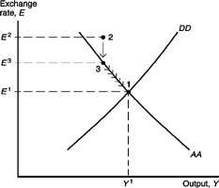
Page Ref: 466-467
Difficulty: Easy

9) Imagine that the economy is at a point on that is below both AA and DD, where both the output and asset markets are out of equilibrium. Which first action is TRUE?
A) The economy will stay at this level in the short run.
B) The exchange rate will first rise to a point on the AA schedule.
C) The exchange rate will first rise to a point on the DD schedule.
D) The AA-DD equilibrium will shift to the position of the economy.
E) The output level will first increase to a position on the DD schedule.
Answer: B
Page Ref: 466-467
Difficulty: Easy

10) Assume the output market adjusts more rapidly than the asset market. A point of disequilibrium that is below both AA and DD will therefore initially result in
A) an increase in output.
B) a decrease in output.
C) a contraction of the money supply.
D) a depreciation of the home currency.
E) an appreciation of the home currency.
Answer: B
Page Ref: 466-467
Difficulty: Easy
17.7 Temporary Changes in Monetary and Fiscal Policy

1) In the short run, with prices fixed, how would an increase in government spending affect the DD-AA equilibrium?
A) It will increase output and appreciate the currency.
B) It will increase output and depreciate the currency.
C) It will decrease output and appreciate the currency.
D) It will decrease output and depreciate the currency.
E) It will increase output and have no effect on the currency.
Answer: A
Page Ref: 468-471
Difficulty: Easy

2) In the short-run, an increase in government purchases will cause
A) a shift of the DD curve to the left and an increase in output.
B) a shift of the DD curve to the right and a decrease in output.
C) a shift of the DD curve to the left and a decrease in output.
D) a shift of the DD curve to the right and an increase in output.
E) a shift of the DD curve the left and an appreciation of the currency.
Answer: D
Page Ref: 468-471
Difficulty: Easy

3) What are two ways the government can use to maintain full employment in an open economy? Also give an example for each.
Answer: There are two types of government policy, monetary and fiscal policy. Examples of monetary policy are changes in the money supply. Examples of fiscal policy are changes in government spending or taxes.
Page Ref: 468-471
Difficulty: Moderate
4) Using a figure show that under full employment, a temporary fiscal expansion would increase output (over-employment) but cannot increase output in the long run.
Answer: A temporarily fiscal expansion will move the economy from DD1 to DD2, and output increases. A permanent fiscal expansion will also shift the AA curve to the left and down. The nominal exchange rate appreciates, i.e. E decreases.

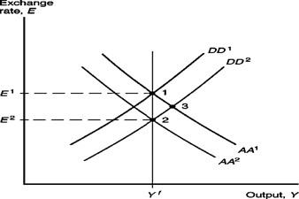
Page Ref: 468-471
Difficulty: Moderate

5) In the short-run, a temporary increase in money supply
A) shifts the DD curve to the right, increases output and appreciates the currency.
B) shifts the AA curve to the left, increases output and depreciates the currency.
C) shifts the AA curve to the left, decreases output and depreciates the currency.
D) shifts the AA curve to the left, increases output and appreciates the currency.
E) shifts the AA curve to the right, increases output and depreciates the currency.
Answer: E
Page Ref: 468-471
Difficulty: Easy

6) In the short-run, a tax increase
A) shifts the DD curve to the right, increases output and appreciates the currency.
B) shifts the AA curve to the left, increases output and depreciates the currency.
C) shifts the AA curve to the left, decreases output and depreciates the currency.
D) shifts the AA curve to the left, increases output and appreciates the currency.
E) shifts the DD curve to the left, decreases output and depreciates the currency.
Answer: E
Page Ref: 468-471
Difficulty: Easy
17.8 Inflation Bias and Other Problems of Policy Formulation

1) What is inflation bias? What measures have governments taken to avoid it?
Answer: Inflation bias is caused when a government is expected to use policy tools to create an economic expansion (such as before an election). Because it is expected, wages and therefore prices are increased. If the government did not pursue the expansionary policy then, there would be a recession! Inflation is increased without the advantage of an increase in output.
Making the central bank independent of the political government is one answer to avoid inflation bias.
Page Ref: 471-472
Difficulty: Moderate

2) Explain and give some examples of governmental policy problems.
Answer: Steady nominal prices give government the power to raise output when it is low. It can also cause them to create a tool that can be used for an economic boom. An example is just before an election. The temptation can be a problem when workers and companies expect it in advance. This will cause a rise in wage demand and prices in the expected expansionary policies. An inflation bias causing high inflation but no average gains in output is also a problem. Others are the difficulty in showing the sources or time of economic changes, and time lags in implementing policies. Impact on the government budget by fiscal policy also causes problems by the way of a tax cut; increase in spending may lead to a government budget deficit that must sooner or later be closed by a fiscal reversal. Policy problem that seem to act quickly have actually a lag time with varying lengths.
Page Ref: 471-472
Difficulty: Moderate

17.9 Permanent Shifts in Monetary and Fiscal Policy

1) If the economy starts in long-run equilibrium, a permanent fiscal expansion will cause
A) an increase in exchange rate, E.
B) a decrease in exchange rate, E.
C) an increase in output, Y.
D) a decrease in output, Y.
E) shifting of the AA curve up and to the right.
Answer: B
Page Ref: 472-477
Difficulty: Easy

2) In long-run equilibrium after a permanent money-supply increase there follows:
A) an increase in exchange rate, E.
B) a decrease in exchange rate, E.
C) an increase in output, Y.
D) a decrease in output, Y.
E) an unchanged exchange rate, E.
Answer: A
Page Ref: 472-477
Difficulty: Easy
3) Which one of the following statements is the MOST accurate?
A) Over time, the inflationary pressure that follows a temporary money supply expansion pushes the price level to its long-run value and returns the economy to full employment.
B) Over time, the inflationary pressure that follows a permanent money supply expansion pushes the price level to its long-run value and returns the economy to full employment.
C) Over time, the inflationary pressure that follows a temporary money supply expansion pushes the price level to its long-run value, but leaves the economy in a state of artificially low employment.
D) Over time, the inflationary pressure that follows a permanent money supply expansion pushes the price level to its long-run value, but leaves the economy in a state of artificially low employment.
E) Over time, the inflationary pressure that follows a permanent money supply expansion pushes the price level beyond its long-run value and lower the level of employment.
Answer: B
Page Ref: 472-477
Difficulty: Easy

4) Using the DD-AA framework, which one of the following statements is the MOST accurate?
A) Only monetary policy can bring the economy to full employment.
B) Only fiscal policy can bring the economy to full employment.
C) Only both monetary and fiscal policies can bring the economy to full employment.
D) Both policies are capable of bringing the economy to full employment and low inflation.
E) Monetary policy by itself or fiscal policy by itself can bring the economy to full employment.
Answer: E
Page Ref: 472-477
Difficulty: Easy

5) Which one of the following statements is the MOST accurate?
A) A permanent increase in the money supply cannot have any short-run effects.
B) A permanent increase in taxes cannot have any short-run effects.
C) A permanent decrease in the money supply cannot have short-run effects.
D) A permanent decrease in taxes cannot have short-run effects.
E) A permanent increase in money demand can be offset with a permanent increase in the money supply of equal magnitude.
Answer: E
Page Ref: 472-477
Difficulty: Easy
6) A permanent increase in the domestic money supply
A) must ultimately lead to a proportional decrease in E, and, therefore, the expected future exchange rate must rise proportionally.
B) must ultimately lead to a proportional decrease in E, and, therefore, the expected future exchange rate must decrease proportionally.
C) must ultimately lead to a proportional rise in E, and, therefore, the expected future exchange rate must rise proportionally.
D) must ultimately lead to a proportional rise in E, and, therefore, the expected future exchange rate must rise more than proportionally.
E) must ultimately lead to a proportional rise in E, and, therefore, the expected future exchange rate must rise less than proportionally.
Answer: C
Page Ref: 472-477
Difficulty: Easy

7) In the short run, a permanent increase in the domestic money supply causes
A) a greater upward shift in the DD curve than that caused by an equal, but transitory, increase.
B) a greater downward shift in the AA curve than that caused by an equal, but transitory, increase.
C) an smaller upward shift in the AA curve than that caused by an equal, but transitory, increase.
D) a smaller downward shift in the AA curve than that caused by an equal, but transitory, increase.
E) a greater upward shift in the AA curve than that caused by an equal, but transitory, increase.
Answer: E
Page Ref: 472-477
Difficulty: Easy

8) In the short run, a permanent increase in the domestic money supply
A) has stronger effects on the exchange rate and output than an equal temporary increase.
B) has stronger effects only on the exchange rate but not on output than an equal temporary increase.
C) has weaker effects on the exchange rate and output than an equal temporary increase.
D) has stronger effects on output, but lower effect the exchange rate than an equal temporary increase.
E) has weaker effects only on the exchange rate than an equal temporary increase.
Answer: A
Page Ref: 472-477
Difficulty: Easy

9) A permanent fiscal expansion
A) shifts the DD and the AA schedules to the right, increasing output.
B) shifts the DD and the AA schedules to the right, decreasing output.
C) shifts the DD to the right and the AA schedule to the left, leaving output the same.
D) shifts the DD to the left and the AA schedule to the left, decreasing output.
E) shifts the DD and the AA schedules to the left, leaving output the same.
Answer: C
Page Ref: 472-477
Difficulty: Easy
10) Explain the following figure:

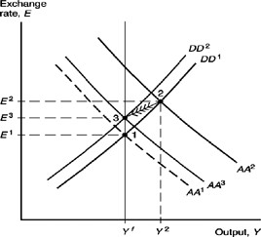

Answer: The figure depicts the effect of a permanent increase in the money supply starting from full employment equilibrium. After the initial increase in the money supply and the move of the AA curve to the right from AA1 to AA2, a steadily increasing price level shifts the AA and the DD schedules to the left until a new long-run equilibrium is reached. Note that point 3 is above point 1, because Ee is permanently higher after a permanent increase in the money supply. The expected exchange rate, Ee, has risen by the same percentage as Ms. Notice that along the adjustment path between the initial short-run equilibrium (point 2) and the long-run equilibrium (point 3) the domestic currency actually appreciates (from E2 to E3) following its initial sharp depreciation (from E1 to E2).
Page Ref: 472-477
Difficulty: Moderate
11) Using the DD-AA framework, show the phenomenon of overshooting. Use a figure to explain when it is taking place.
Answer: The figure below shows the phenomenon of overshooting. A permanent increase in the money supply starting from full employment equilibrium will shift the AA curve to the right from AA1 to AA2. Now, a steadily increasing price level shifts the AA and the DD schedules to the left until a new long-run equilibrium is reached. Note that point 3 is above point 1, because Ee is permanently higher after a permanent increase in the money supply. The expected exchange rate, Ee, has risen by the same percentage as Ms. Notice that along the adjustment path between the initial short-run equilibrium (point 2) and the long-run equilibrium (point 3) the domestic currency actually appreciates (from E2 to E3) following its initial sharp depreciation (from E1 to E2). This exchange rate behavior is an example of overshooting, in which the exchange rate's initial response to some change is greater than its long-run response.

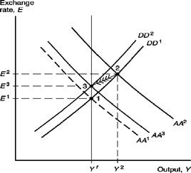
Page Ref: 472-477
Difficulty: Moderate

12) Demonstrate how a permanent fiscal expansion will not increase output in the long run.
Answer: (1) E on Y-axis, Y on X-axis
(2) DD shifts right
(3) temporary equilibrium where E lower and Y increased
(4) permanent increase in demand caused by increase in G causes currency to appreciate: AA shifts left
(5) therefore Y returns to original levels, E decreases even more
RESULT of permanent fiscal expansion: currency appreciation, output does not change. This effect is called "crowding out."
Page Ref: 472-477
Difficulty: Moderate
13) Show the effects of a permanent increase in the money supply.
Answer:
(1) AA-shifts right-increase in Y and E both higher than if money supply change was temporary rising price level makes AD decrease, DD shifts left
(2) rising prices also reduce real money supply, so AA shifts left (although not all the way back to original position)
(3) AA and DD reach short run equilibrium at an E that is higher than initially, but lower than the short run effects of the shift.
(4) Output returns to initial level because higher prices reversed the effect of the initial depreciation on Aggregate Demand.
Page Ref: 472-477
Difficulty: Moderate

14) Using the DD model, explain what happens to out put when Government demands increase. Use a figure to explain when it is taking place.
Answer: The figure below shows the G1 to G2 raises output at every level of the exchange rate. The change shifts the DD to the right. Which in turns increases output to Y2.

Page Ref: 472-477
Difficulty: Easy

17.10 Macroeconomic Policies and the Current Account

1) Which of the following is TRUE of the current account balance?
A) Monetary expansion has no effect on the current account balance.
B) Monetary expansion decreases the current account balance.
C) Fiscal expansion increases the current account balance.
D) Fiscal expansion has no effect on the current account balance.
E) Monetary expansion increases the current account balance.
Answer: E
Page Ref: 477-478
Difficulty: Easy
2) In the short run
A) monetary expansion causes the CA to increase & fiscal expansion causes the CA to decrease.
B) monetary expansion causes the CA to decrease & fiscal expansion causes the CA to decrease.
C) monetary expansion causes the CA to increase & fiscal expansion causes the CA to increase.
D) monetary expansion causes the CA to decrease & fiscal expansion causes the CA to increase.
E) monetary expansion causes the CA to increase & the effects of fiscal expansion are ambiguous.
Answer: A
Page Ref: 477-478
Difficulty: Easy

3) Which statement best describes the current account balance in the short run?
A) Monetary expansion lowers the current account balance.
B) Monetary expansion keeps the current account balance the same.
C) Fiscal expansion increases the current account balance.
D) Fiscal expansion keeps the current account balance the same.
E) Monetary expansion increases the current account balance.
Answer: E
Page Ref: 477-478
Difficulty: Easy

17.11 Gradual Trade Flow Adjustment and Current Account Dynamics

1) According to historical data, what is the effect of a sharp change in the current account on the exchange rate (both in the short and long run)?
A) At first, home currency will depreciate as CA balance falls, but over time, currency will begin to depreciate.
B) At first, home currency will appreciate as CA balance falls, but over time, currency will begin to depreciate.
C) At first, home currency will appreciate as CA balance rises, but over time, currency will begin to depreciate.
D) At first, home currency will depreciate as CA balance falls, but over time, currency will begin to appreciate.
E) At first, home currency will appreciate as CA balance falls, but over time, currency will begin to appreciate.
Answer: B
Page Ref: 478-481
Difficulty: Easy
2) Which two time periods did the U.S. begin to experience a sharp increase in Current Account deficits?
A) 1981, mid-1990s
B) 1971, mid-1990s
C) 1961, mid-1990s
D) 1971, mid-1980s
E) 1985, mid-1990s
Answer: A
Page Ref: 478-481
Difficulty: Easy

3) The J-curve illustrates which of the following?
A) the effects of depreciation on the home country's economy
B) the immediate increase in current account caused by a currency depreciation
C) the gradual adjustment of home prices to a currency depreciation
D) the short-term effects of depreciation on the current account
E) the Keynesian view of international trade dynamics
Answer: D
Page Ref: 478-481
Difficulty: Easy

4) The percent by which import prices rise when the home currency depreciates by 1% is the degree of
A) pass-forward from exchange rates to import prices.
B) pass-through from exchange rates to import prices.
C) pass-on from exchange rates to import prices.
D) roll-forward from exchange rates to import prices.
E) pass-beyond from exchange rates to import prices.
Answer: B
Page Ref: 478-481
Difficulty: Easy

5) In practice, many U.S. import prices tend to rise by only around
A) 1/4 of a typical dollar depreciation over the following year.
B) 1/3 of a typical dollar depreciation over the following year.
C) 1/2 of a typical dollar depreciation over the following year.
D) 2/3 of a typical dollar depreciation over the following year.
E) 2/5 of a typical dollar depreciation over the following year.
Answer: C
Page Ref: 478-481
Difficulty: Easy

6) Describe what is a J Curve?
Answer: The time lag with which real currency depreciation improves the current account. The current account is measured in terms of domestic output, and can drop quickly right after real currency depreciation because most import and export orders are placed several months in advance. In the first few months after the depreciation, export and import volumes therefore may reflect buying decisions that were made on the basis of the old real exchange rate.
Page Ref: 478-481
Difficulty: Moderate
17.12 The Liquidity Trap

1) If a country's nominal interest rate is zero, then
A) the country's economy is in a liquidity trap.
B) exchange rates with other countries are likely to decline.
C) exchange rates with other countries are likely to increase.
D) monetary policy is likely to be very effective in stimulating the economy.
E) the country's economy has achieved monetary equilibrium.
Answer: A
Page Ref: 481-485
Difficulty: Moderate

2) When an economy is in a liquidity trap
A) monetary policy cannot be used to influence the exchange rate.
B) monetary policy can be used to drive interest rates down, but not to drive them up.
C) there is an excess demand for bonds.
D) people and institutions avoid holding cash balances.
E) it can escape only by introducing a hard, or illiquid, currency.
Answer: A
Page Ref: 481-485
Difficulty: Moderate

3) Which of the following is an example of an "unconventional monetary policy" by a central bank?
A) The purchase of specific categories of assets with new money.
B) The sale of long-term government bonds for foreign exchange.
C) the purchase of long-term government bonds using foreign exchange.
D) raising reserve requirements by commercial banks.
E) selling gold reserves.
Answer: A
Page Ref: 481-485
Difficulty: Moderate

4) If an economy is in a liquidity trap, then the nominal interest rate is ________ and the only effective policy that can be used to stimulate the economy is ________.
A) zero or negative; expansionary fiscal policy
B) zero or negative; expansionary monetary policy
C) high and rising; contractionary monetary policy
D) high and rising; expansionary monetary policy
E) high and rising; expansionary fiscal policy
Answer: A
Page Ref: 481-485
Difficulty: Moderate
17.13 Appendix 1 to Chapter 17: Intertemporal Trade and Consumption Demand

1) An intertemporal budget constraint
A) requires the present value of consumption to be equal to the present value of production.
B) requires total spending in each period to be equal to total consumption in each period.
C) does not take into account the ability to borrow or loan goods domestically.
D) categorizes income into permanent and temporary income.
E) limits consumption to the amount produced in each time period.
Answer: A
Page Ref: 490-491
Difficulty: Easy

2) If consumers experience an increase in lifetime income, current spending will ________, current saving will ________, and future spending will ________.
A) increase; increase; increase
B) increase; decrease; decrease
C) increase; decrease; increase
D) increase; increase; decrease
E) decrease; increase; increase
Answer: A
Page Ref: 490-491
Difficulty: Easy

3) If consumers experience an decrease in lifetime income, current spending will ________, current saving will ________, and future spending will ________.
A) decrease; decrease; decrease
B) increase; decrease; decrease
C) increase; decrease; increase
D) increase; increase; decrease
E) decrease; increase; increase
Answer: A
Page Ref: 490-491
Difficulty: Easy

17.14 Appendix 2 to Chapter 17: The Marshall-Lerner Condition and Empirical
Estimates of Trade Elasticities

1) One implication of an empirical investigation of the Marshall-Lerner condition is that, in the ________, a real ________ in a nation's currency is likely to ________ the country's current account balance.
A) long-run; depreciation; improve
B) short-run; depreciation; improve
C) long-run; appreciation; improve
D) short-run; appreciation; improve
E) short-run but not the long-run; appreciation; improve
Answer: A
Page Ref: 492-494
Difficulty: Easy
2) The Marshall-Lerner condition holds that a country's current account balance will ________ in response to a real ________ in a nation's currency if ________.
A) improve; depreciation; sum of the price elasticities of export and import demand exceeds 1
B) worsen; depreciation; sum of the price elasticities of export and import demand exceeds 1
C) improve; appreciation; sum of the price elasticities of export and import demand exceeds 1
D) improve; appreciation; sum of the price elasticities of export and import demand exceeds 0
E) worsen; depreciation; sum of the price elasticities of export and import demand exceeds 0
Answer: A
Page Ref: 492-494
Difficulty: Moderate

3) A real depreciation of a nation's currency gives rise to the ________ effect and the ________ effect on the current account.
A) volume; value
B) depletion; expansion
C) surplus; deficit
D) output; trade
E) price; profit
Answer: A
Page Ref: 492-494
Difficulty: Easy

4) The Marshall-Lerner Condition states that, all else equal
A) nominal appreciation improves the current account if export and import volumes are sufficiently elastic with respect to the real exchange rate.
B) real depreciation improves the current account if export and import volumes are sufficiently inelastic with respect to the real exchange rate.
C) real appreciation improves the current account if export and import volumes are sufficiently elastic with respect to the real exchange rate.
D) real depreciation improves the current account if export and import volumes are sufficiently elastic with respect to the real exchange rate.
E) the sum of import and export elasticities must be equal to one in order for depreciation to occur.
Answer: D
Page Ref: 492-494
Difficulty: Easy

